**Circuit 1: Capacitor charging/discharging display circuit**

The 2 switches controls charging and discharging, and the 2 LEDs intensity represent the current being charged/discharged by the capacitor.

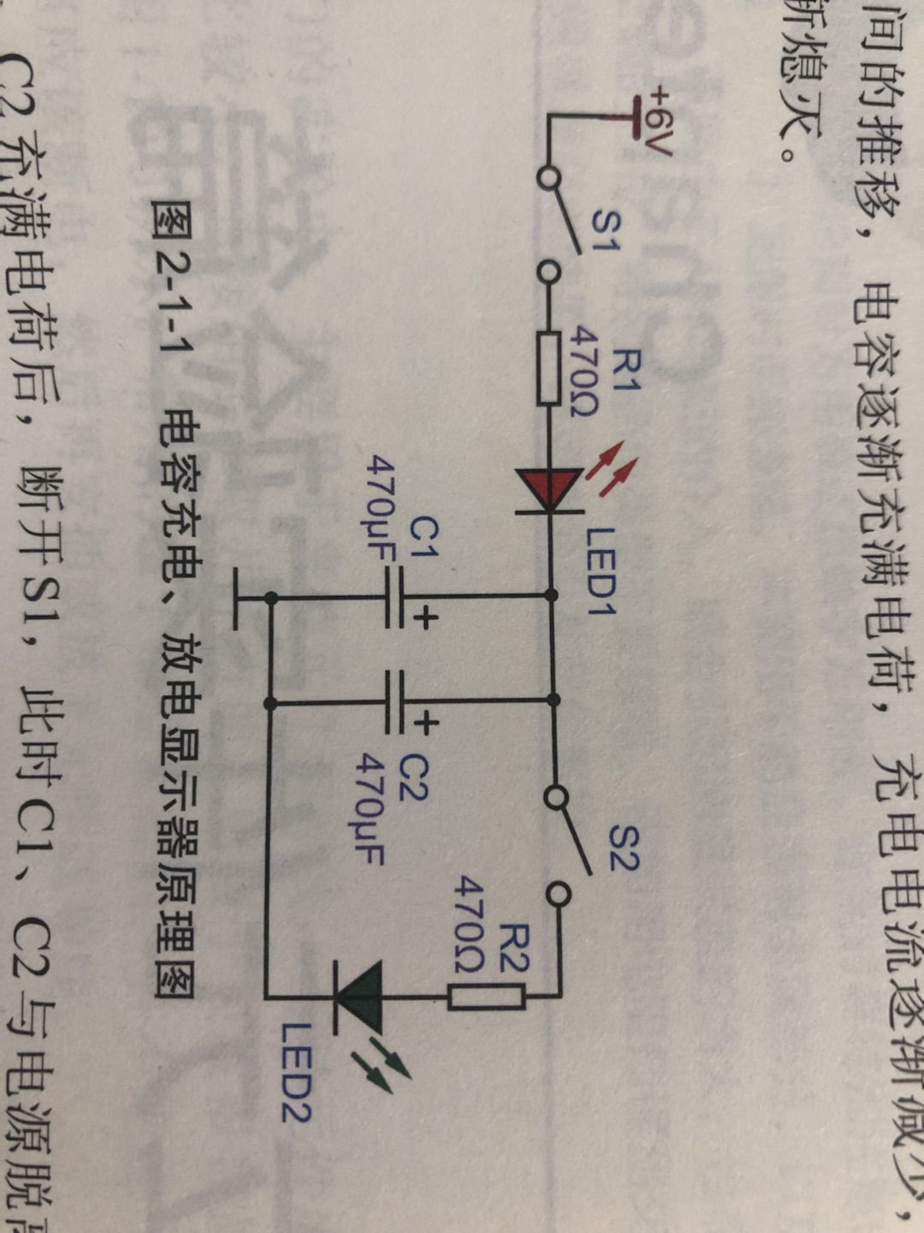

An example of the assembly diagram. In practical, you can use other types of switches or pushbuttons. Dexter, you **DO NOT** need to follow the layout as shown in the picture, I am just giving an example for reference.

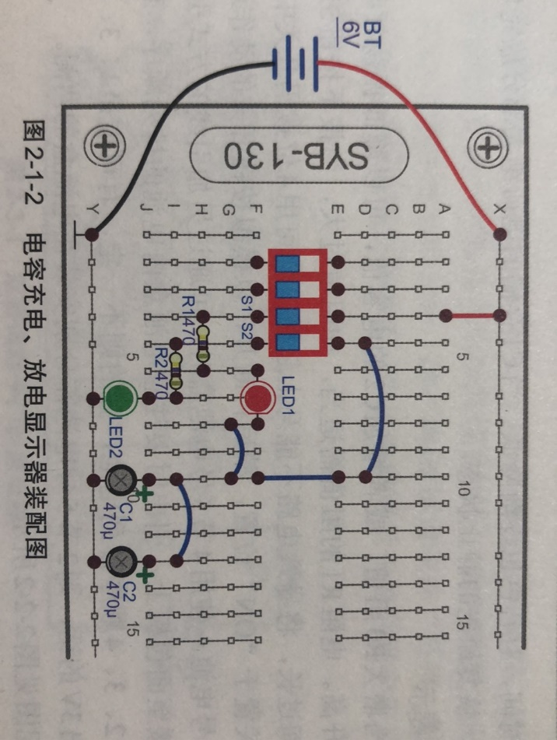

For LAB-on-the-go, show this measurement on breadboard:

* Use Zoolark oscilloscope to probe the voltage at C1/C2, change the time/div to 500ms and observe the waveform while toggling the switches (On Zoolark interface, you can put the screen it as blank black for now).

**Circuit 2: A simple alarm bell with weird tone**

The NPN transistor V1 and PNP transistor V2 form an unstable positive feedback structure which indicates the circuit can oscillate without given any signal input. At initial state when S1 is open, all components stay rest. When S1 is closed, C1 charges up so the base voltage of V1 also rises. When the base voltage is around 0.7V, V1 is activated, and oscillation occurs. (Use pushbutton for S1 is preferred, do not use toggle/sliding switches)

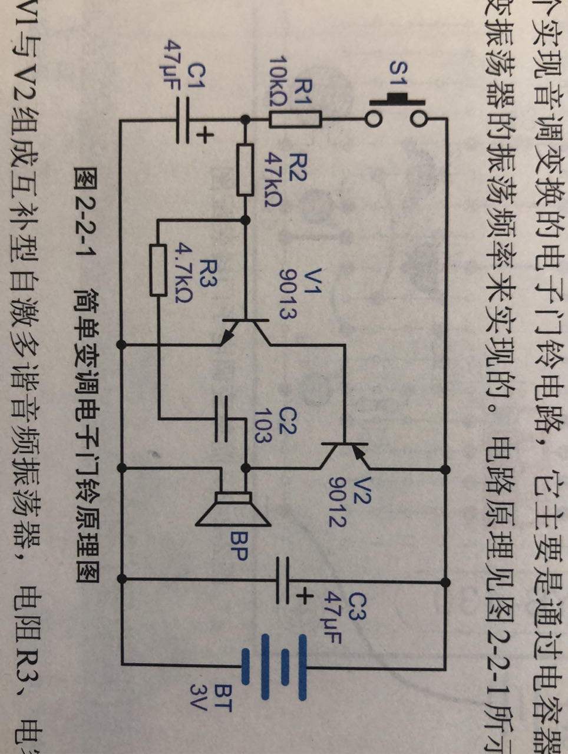

Use 4.5V

On breadboard, use Zoolark to probe the voltage of C1 while the pushbutton is pressed and released

* Increasing R3 or C2 can decrease the oscillating frequency and vice versa

**Circuit 3: Alternating LED flashlights**

This is a typical astable multivibrator circuit built by BJTs.

Here is some explanation: <https://learnabout-electronics.org/Oscillators/osc41.php>

You can also use circuitJS to simulate: https://www.eimtechnology.com/war/circuitjs.html

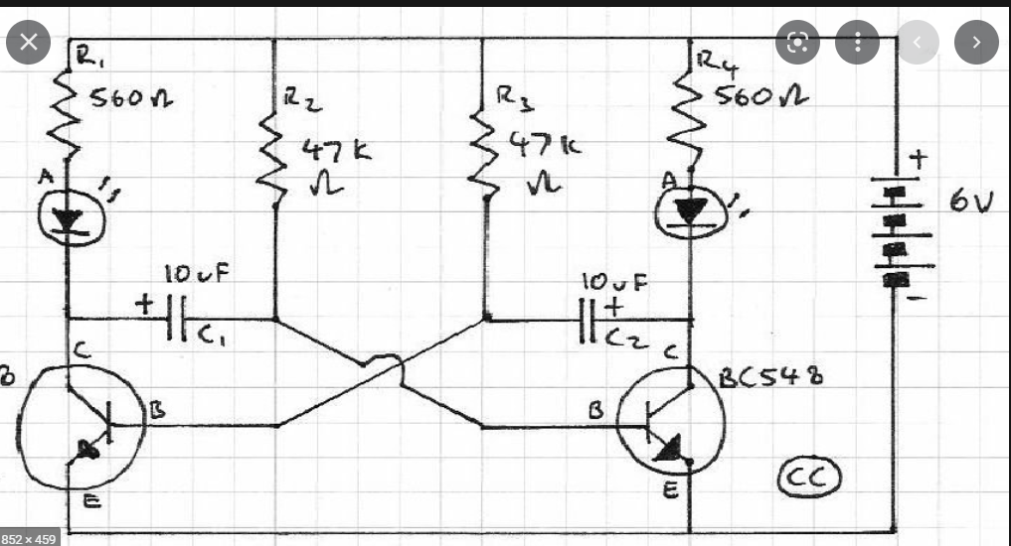

In breadboard circuit, use Zoolark oscilloscope CH1 to probe the collector voltage of left BJT and CH2 to probe the collector voltage of right BJT.

**Circuit 4: A better Alarm bell with dual tones**

This circuit combines the complementary oscillator (V3, V4) and the astable multivibrator (v1, v2). When S1 is pressed, two circuits operate simultaneously so circuit can generate two tones, more like the sound of a real alarm bell.

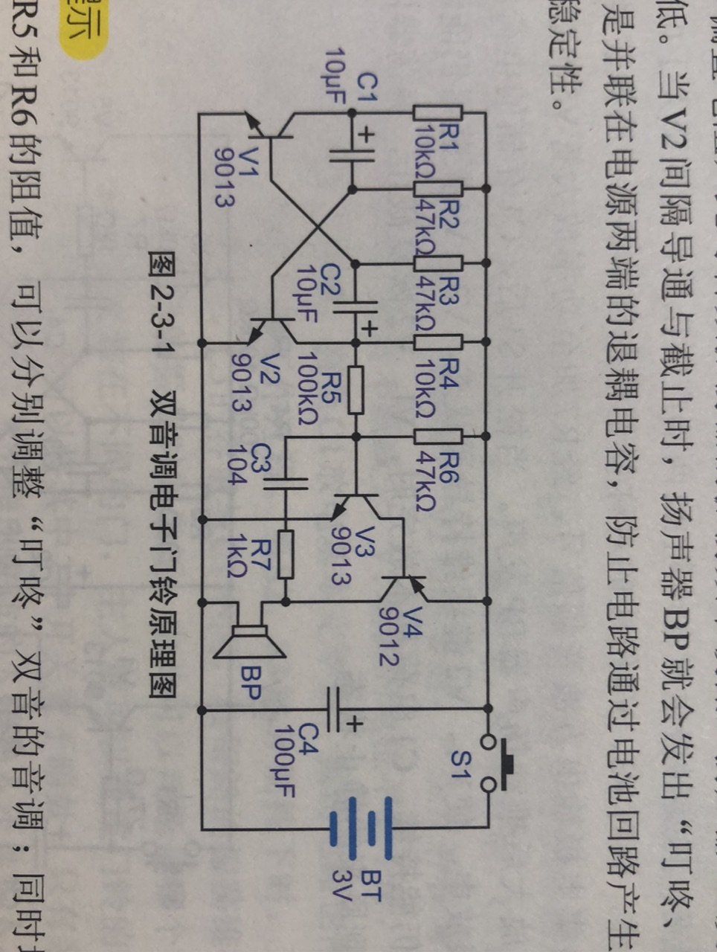

4.5V

This circuit has more components, first step is to build the left astable multivibrator part, power it up and see if there is output at C2; then build the right oscillator.

While testing, changing R5 and R6 can modify the pitch of the tone.

Also, modify the value of R2 and R3 can change the alternating frequency of the two tones.

**Circuit 5: A more secure alarm bell with multiple duration**

This circuit has 3 switches that all can control the alarm, however are configured with different duration of sound. The 3 capacitors are different values. Larger capacitors hold more electrons so it supports longer time of oscillation when being pressed…same idea applies to C2, C3…So you can identify which switch is being pressed by telling the sound.

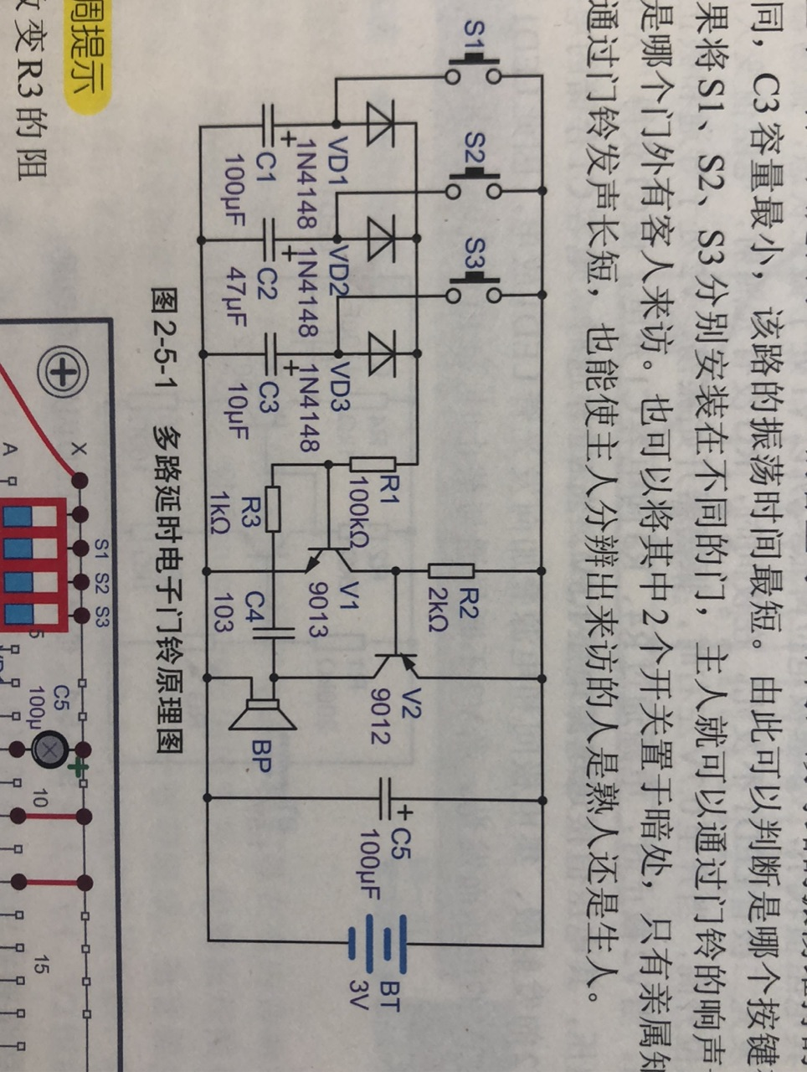

4.5V

Changing R3 or C4 can vary the pitch of the tone.

**Circuit 6: Sound controlled LED flashlight**

Microphone converts sound into analog signal. But this signal is too weak so it must be amplified. The capacitor C1 blocks the DC portion of the signal so the AC part can be amplified by the two stage amplified formed by V1 and V2. The current flows into the collector of V2 (or R4 and LED) is changing in regards of the sound captured by the microphone

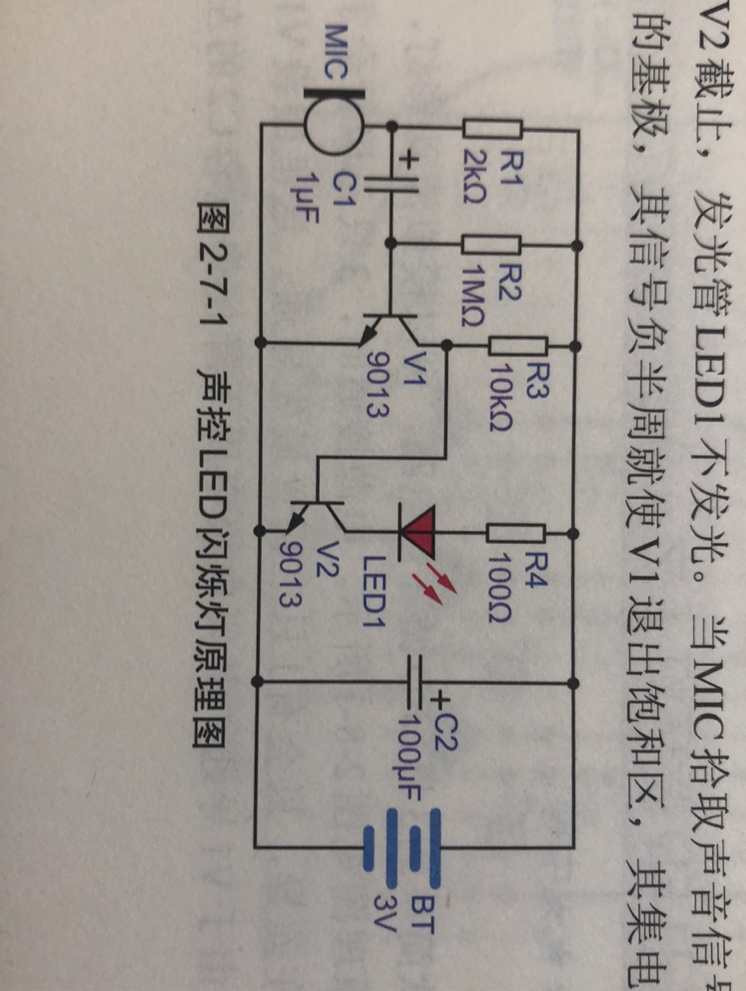

300ohm

5V

While building, build the first stage amplifier with V1 and R3 first, and use Zoolark to see you can detect the output at collector of V1 while speaking to the microphone. Then connect to the second stage by completing V2, R4, LED, C2.

**Circuit 7: Light Controlled Switch**

This circuit is simple, RG is a light dependent resistor (LDR), which forms a voltage divider with RP1. When light is weak, RG has high resistance so the base voltage of V1 is low and all BJTs are off. When light is strong, V1 and V2 are ON, so the relay closes switch and LED1 will be turned on.

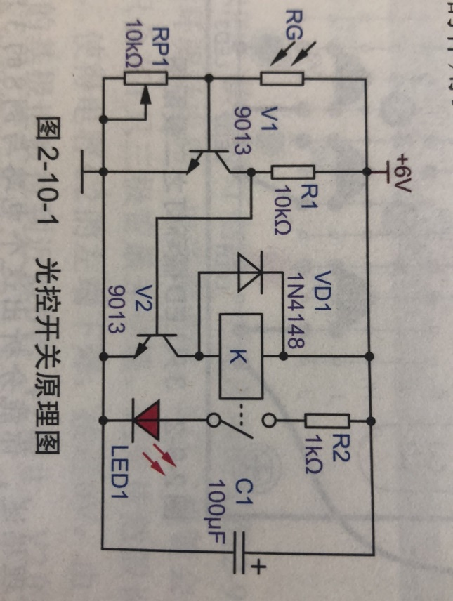

While playing, you can use VEGO and set to resistor measurement mode, measure the resistance of RG at different light exposure to see how this works.

Please also refer this diagram to see how relay is connected.

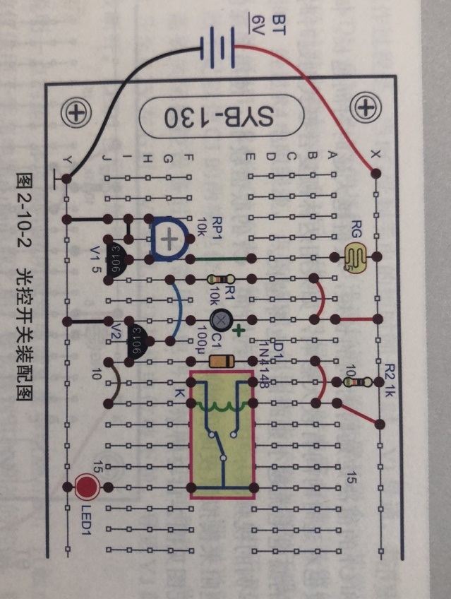 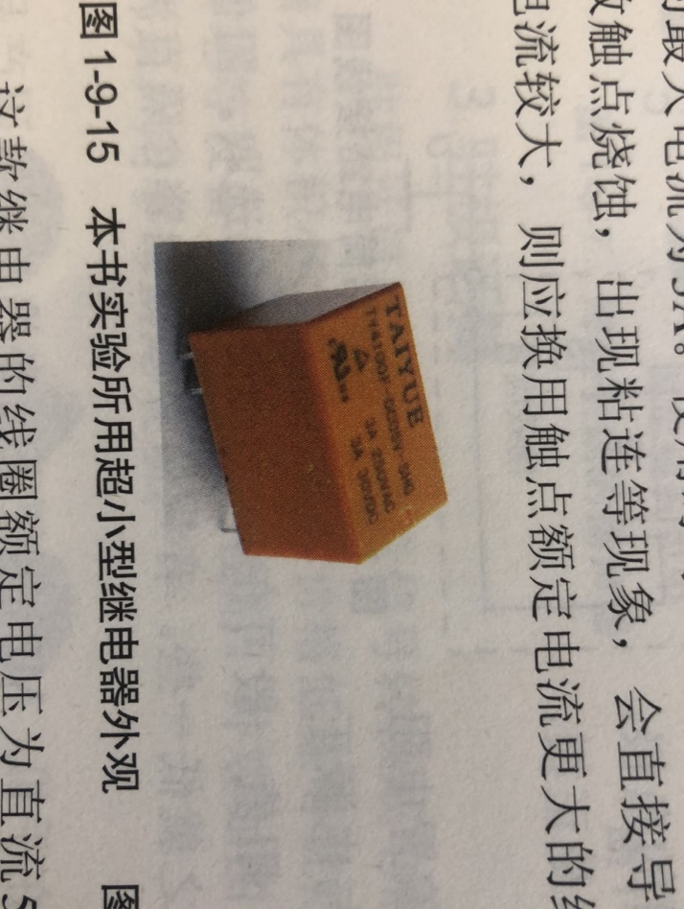

**Circuit 8: Light Controlled Switch**

Almost same with circuit7 except that this circuit adds a RC circuit (R1, C1) for delay. The larger the value, the longer the delay.

